
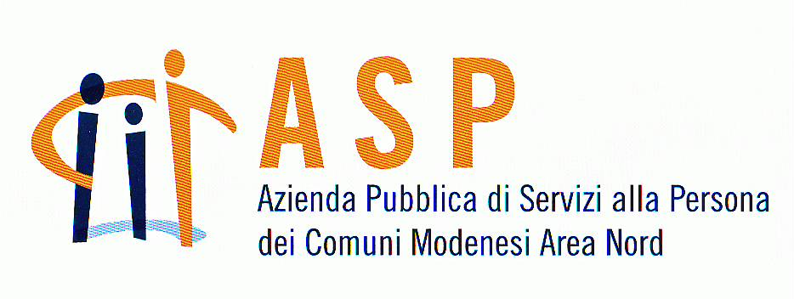
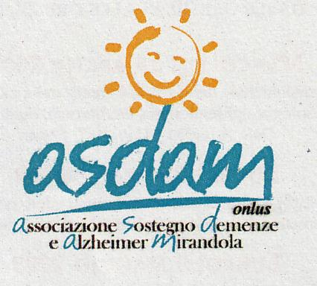

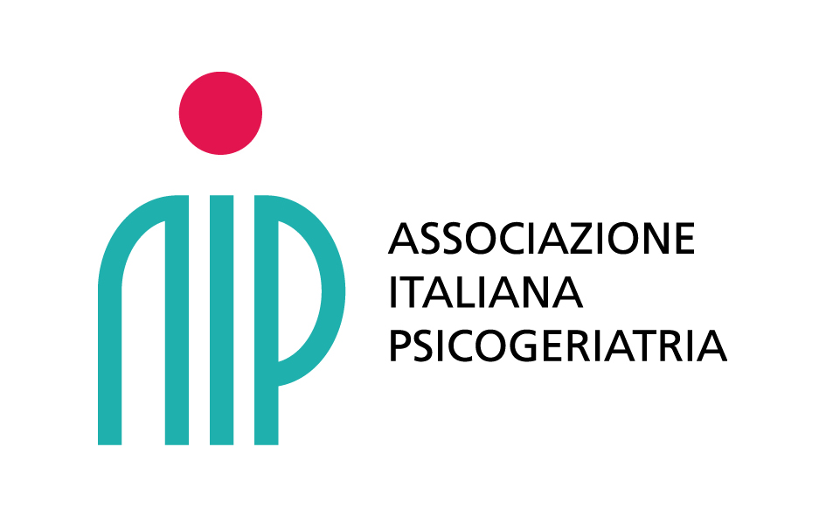
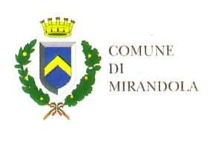

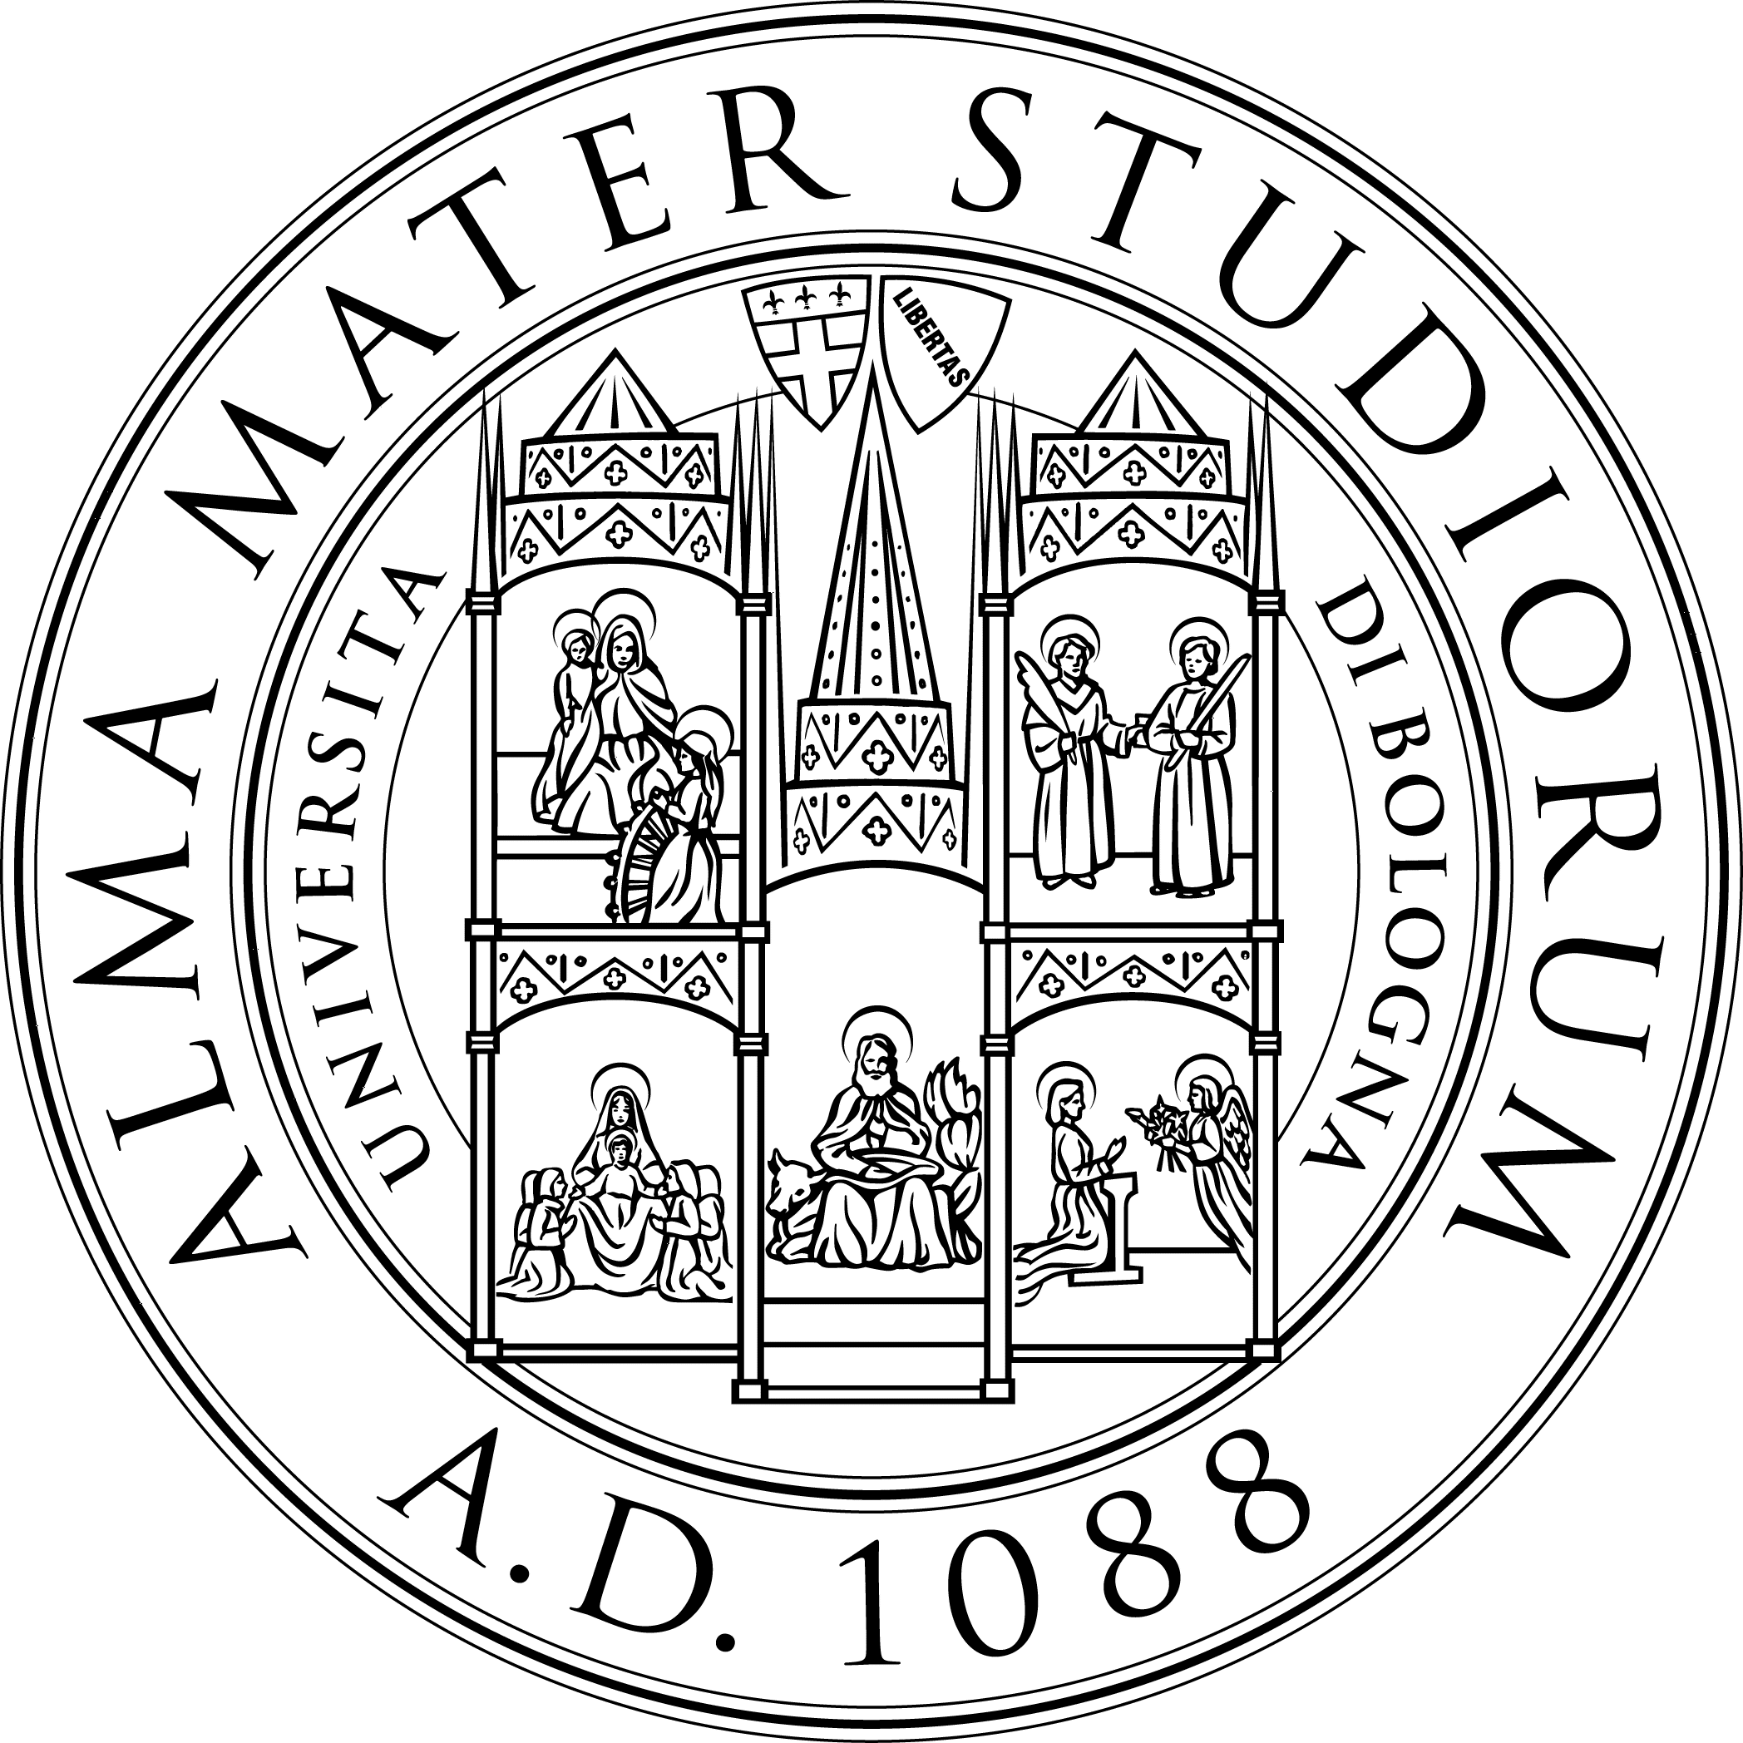
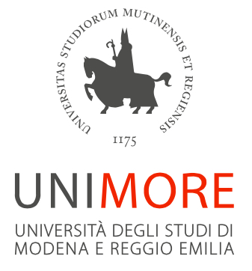

As part of the event FESTIVAL MEMORY 9-12 June 2016

Mirandola conference June 10, 2016
Auditorium " Rita Levi Montalcini " Mirandola

Active aging and cognitive reactivation : the prevention and treatment models .

9:00 Opening of the Conference
Mayor of Mirandola

9:15 to 9:45 Introduction to the conference / Intervention ?
Massimo Annichiarico
Director General AUSL Modena

I SESSION 9:45 to 11:15 hours
Moderated by: Marco Bertolotti , Rabih Chattat

9:45 to 10:15 Aging , Memory and fragility disorders
Andrea Fabbo
Program Dementias AUSL Modena

10.15 to 10:45 Can prevent dementia through active aging ?
Paolo Frigio Nichelli / Annalisa Chiari
Director Integrated Department of Neurosciences , University of Modena and Reggio Emilia

10:45 to 11:15 The importance of psychosocial interventions : the state
Esme Moniz Cook
Consultant Professor of Clinical Psychology , University of Hull , UK

11:15 to 11:30 Coffee break

II SESSION 11:30 to 13:00 hours
Moderated by: Antonella Carafelli

11:30 to 12:00 Reminiscence
Samantha Pradelli
Clinical Psychologist , Conegliano Veneto (TV )

12:00 to 12:30 The cognitive stimulation ( CST )
Simona Gardini
University of Parma

12:30 to 13:00 Emotional health and cognitive health
Rabih Chattat
Department of Psychology , University of Bologna

13:00 to 14:00 lunch break
SESSION III 14:00 to 17:30
Moderation by: Luisa Bartorelli , Aldo Biolcati

14:00 to 14:30 The memory training
Luc Pieter De Vreese
Italian association of Psychogeriatrics

14:30 to 15:00 Environment and occupations
Simona Rodio Occupational therapist , Bachelor SUPSI ,
Department of Health Canton Ticino , Switzerland

15:00 to 15:30 Cognitive stimulation and physical activity : the COGS CLUB
Jackie Tuppen
Admiral Nurse , Kent , UK

15:30 to 16:00 The model of " COGS CLUB " : the Modena experience
Petra Bevilacqua
Psychologist Asdam Mirandola , ASP Terre d ' Embankment Carpi , Opera Pia Castiglioni Formigine

16:00 to 16:30 Memory, music and art
Silvia Ragni
Psychologist and music therapist ,
Dementia Day Centre , Fondazione Roma

16:30 to 17:00 Memory and sensory stimulation
Annalisa Bonora , Giacomo Menabue
Psychologist and coach of psychiatric rehabilitation ,
ASP Union Common Modenesi Area North

17:00 to 17:30 Discussion and filling out the questionnaire ECM

Scientific secretary :
Lucia Bergamini , Petra Bevilacqua , Andrea Fabbo , Marina Turci

Organizing Committee:
Program Dementias AUSL Modena
Luigi De Salvatore l.desalvatore@ausl.mo.it
Tel.059.435227 fax 059-435222

